Getting Ready to run the code.

1. Downloading and installing Arduino software [here](https://www.arduino.cc/en/software)
2. Setting up Arduino IDE for NodeMCU.
   1. As there is a lot of boards out there, the default Arduino software is only compatible for the Arduino boards. <https://www.arduino.cc/en/hardware> So we will need to do additional steps to configure the Arduino software to be able to understand the NodeMCU.

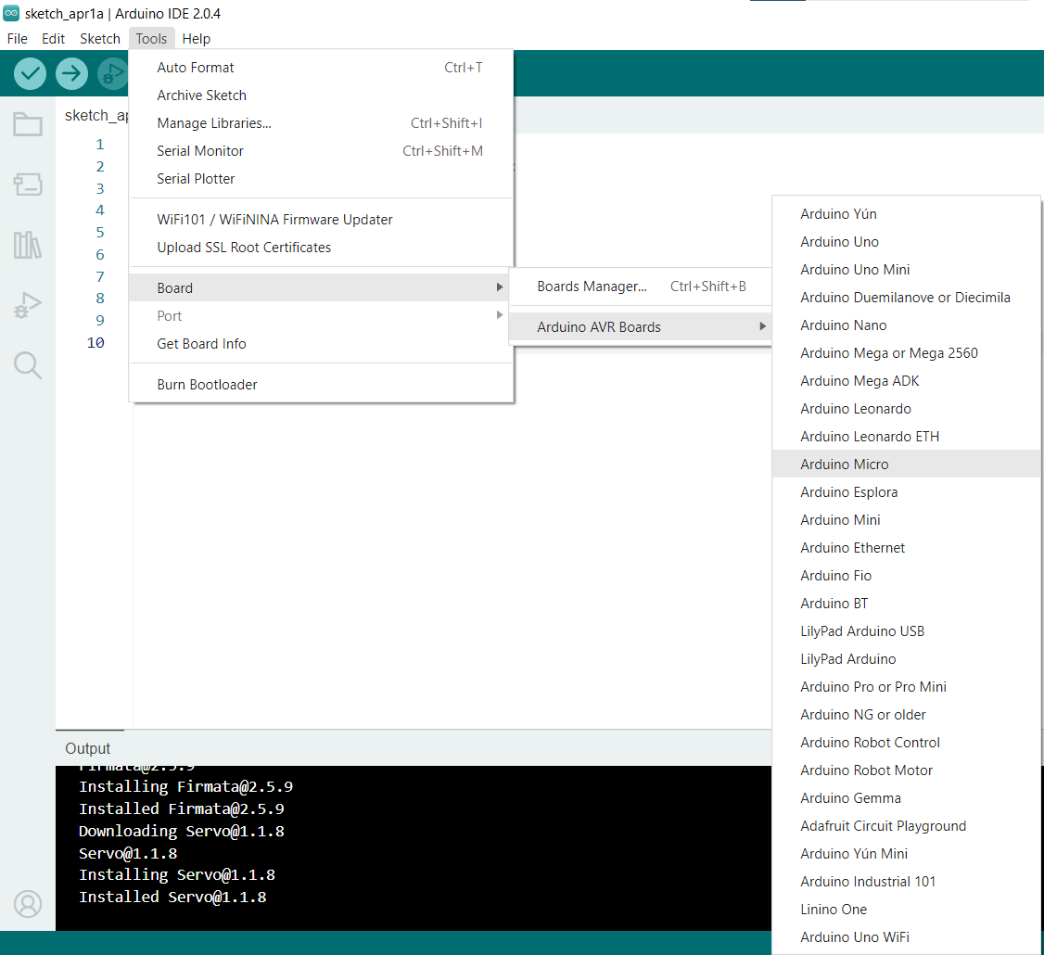

As shown in the screenshot above, there is only support for all the Arduino boards. To install the NodeMCU board, go to File -> Preferences and under the Additional Board Manager URLs, paste the following URL.

<http://arduino.esp8266.com/stable/package_esp8266com_index.json>

Once completed, you will need to **go to Tools -> Boards Manager**

**After clicking on the boards manager, search for ESP8266 in the search bar and click on install.**

**Upon successful installation, you can navigate back to Tools -> Board and you will be able to see that you have ESP8266 installed.**

**If you were to open up the code for the project, you will realize that there are some #include statements at the top.**

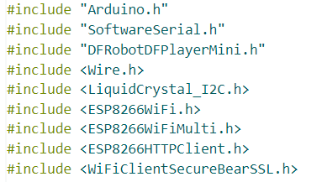**These are the libraries that I am using for the project.**

**If you were to hit the Tick icon at the top left of the screen right after you open up the code, you will get the following error message. This is because you haven’t selected the board that this code is meant for.**

**So you can click on the dropdown list on select board and search for node under the board list and select the NodeMCU 1.0.**

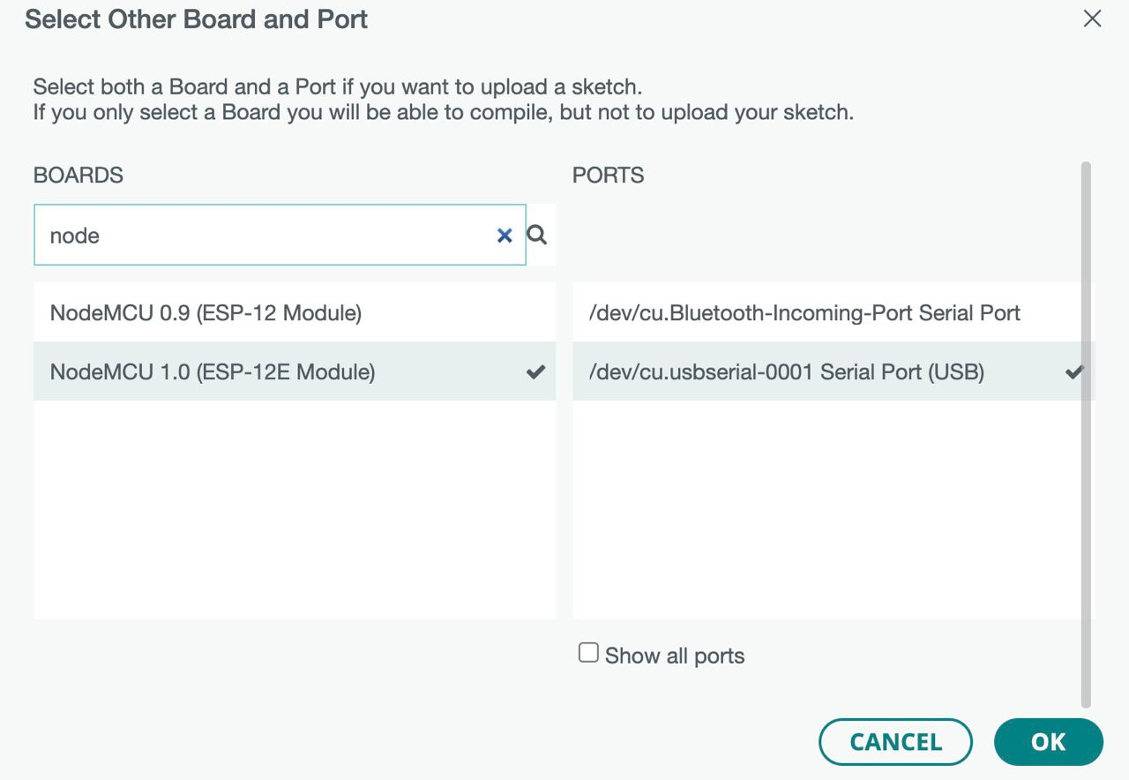

**After selecting the board and clicking on the Verify icon, you will most likely get the following error message.**

**This is because we are using additional libraries that are not part of Arduino and we will need to install these packages.**

|  |  |
| --- | --- |
| **Error Message** | **Link to download** |
| **DFRobotDFPlayerMini.h: No such file or directory** | **https://github.com/DFRobot/DFRobotDFPlayerMini** |
| **LiquidCrystal_I2C.h: No such file or directory** | **https://github.com/fdebrabander/Arduino-LiquidCrystal-I2C-library** |

**To install an additional library into Arduino, the library MUST be in a .zip file format. Then go to Sketch -> Include Library -> Add .ZIP Library and navigate to the .zip file that you have downloaded.**

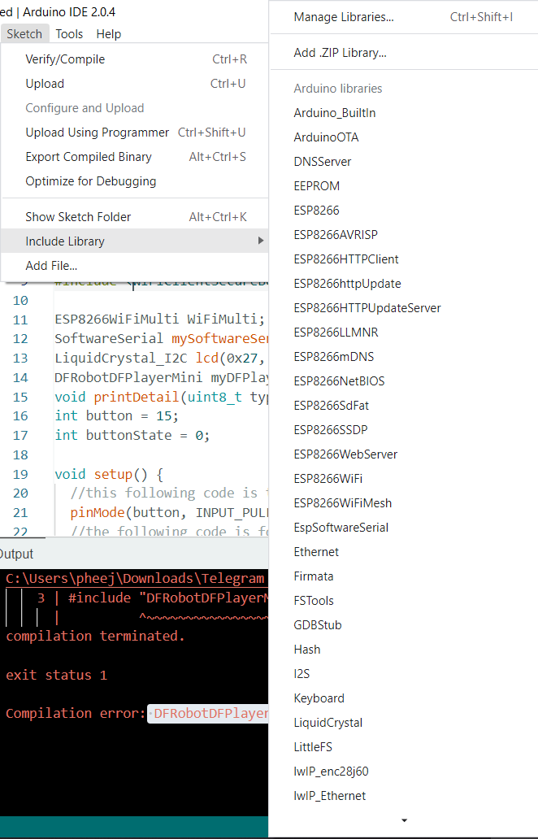

**You will see the following output once you have installed the library successfully.**

**Once you have installed the above 2 libraries, you should be able to compile successfully.**

